

KAMPUS SUNGAI PETANI

FACULTY OF INFORMATION SCIENCE STUDIES, COLLEGE OF COMPUTING, INFORMATICS AND MEDIA

DIPLOMA IN LIBRARY INFORMATICS

(IM144)

(PROGRAMMING FOR LIBRARIES)

(IML208)

**ASSIGNMENT 1: INDIVIDUAL ASSIGNMENT**

**PREPARED BY: MUHAMAD LUQMAN HAQEEM BIN NORHESAM**

**(2022487428)**

**(KIM1443B)**

**PREPARED FOR:**

**SIR AIRUL SHAZWAN BIN NORSHAHIMI**

**SUBMISSION: WEEK 12**



**STUDENT PLEDGE OF ACADEMIC INTEGRITY**

As a student of Universiti Teknologi MARA (UiTM), it is my responsibility to act in accordance with UiTM’s academic assessment and evaluation policy. I hereby pledge to act and uphold academic integrity and pursue scholarly activities in UiTM with honesty and responsible manner. I will not engage or tolerate acts of academic dishonesty, academic misconduct, or academic fraud including but not limited to:

a. **Cheating:** Using or attempt to use any unauthorized device, assistance, sources, practice or materials while completing academic assessments. This include but not limited to copying from another, allowing others to copy, unauthorized collaboration on an assignment or open book tests, or engaging in any act or conduct that can be construed as cheating.

b. **Plagiarism:** Using or attempts to use the work of others (ideas, design, words, art, music, etc.) without acknowledging the source; using or purchasing materials prepared by another person or agency or engaging in other behavior that a reasonable person would consider as plagiarism.

c. **Fabrication:** Falsifying data, information, or citations in any academic assessment and evaluation.

d. **Deception:** Providing false information with intend to deceive an instructor concerning any academic assessment and evaluation.

e. **Furnishing false information:** Providing false information or false representation to any UiTM official, instructor, or office.

With this pledge, I am fully aware that I am obliged to conduct myself with utmost honesty and

integrity. I fully understand that a disciplinary action can be taken against me if I, in any manner, violate this pledge.

**Name : MUHAMAD LUQMAN HAQEEM BIN NORHESAM**

**Matric Number : 2022487428**

**Course Code : IML208**

**Programme Code :- IM144**

**Faculty / Campus : UiTM Kampus Sungai Petani**

Powered by TCPDF (www.tcpdf.org)

Bahagian Pentaksiran & Penilaian Akademik 0404/2021

INTRODUCTION

Programming refers to a technological process for telling a computer which tasks to perform in order to solve problems. You can think of programming as a collaboration between humans and computers, in which humans create instructions for a computer to follow (code) in a language computers can understand.

Computer programming is the process of writing code to facilitate specific actions in a computer, application or software program, and instructs them on how to perform. Computer programmers are professionals that create instructions for a computer to execute by writing and testing code that enables applications and software programs to operate successfully.

Computers can do amazing things, from basic laptops capable of simple word processing and spreadsheet functions to incredibly complex supercomputers completing millions of financial transactions a day and controlling the infrastructure that makes modern life possible. But no computer can do anything until a computer programmer tells it to behave in specific ways. That’s what computer programming is all about.

SCREENSHOT OF GUI

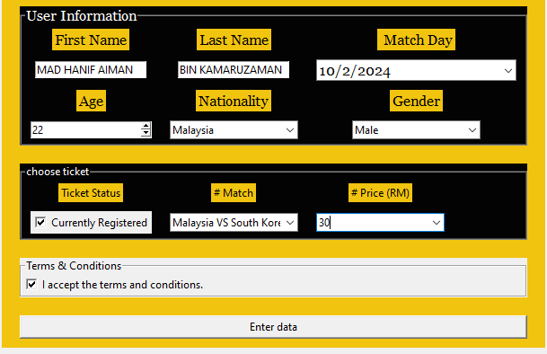

SCREENSHOT OF DATABASE

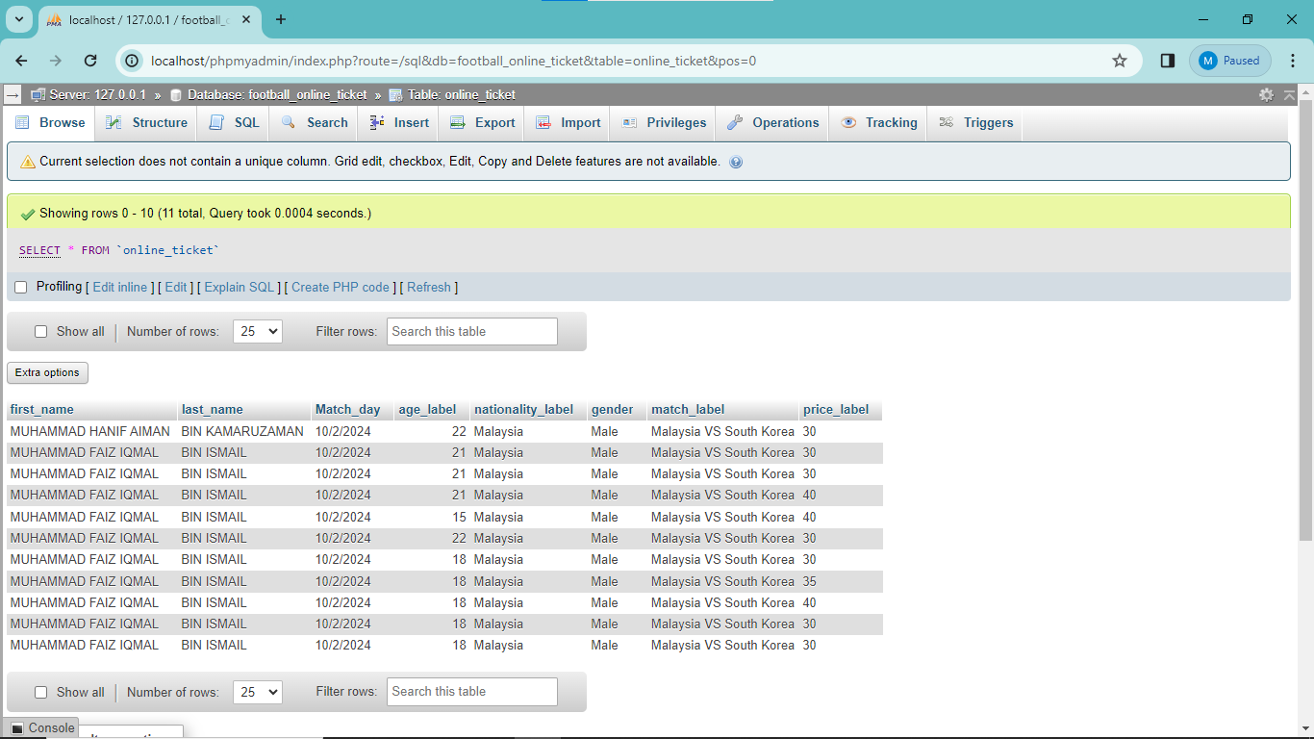

SCREENSHOT OF CODE

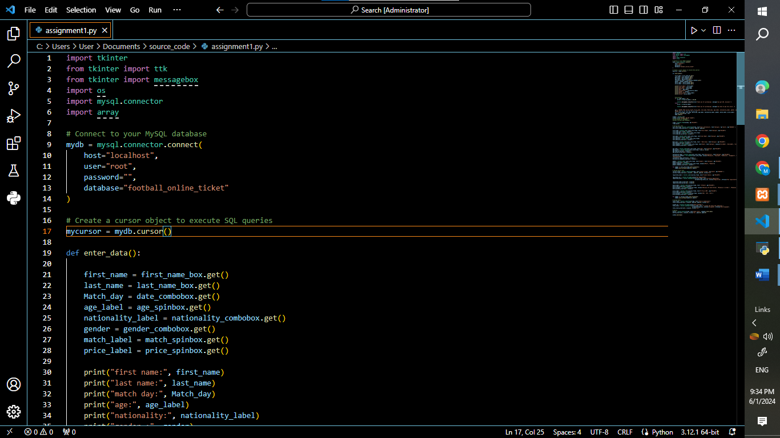

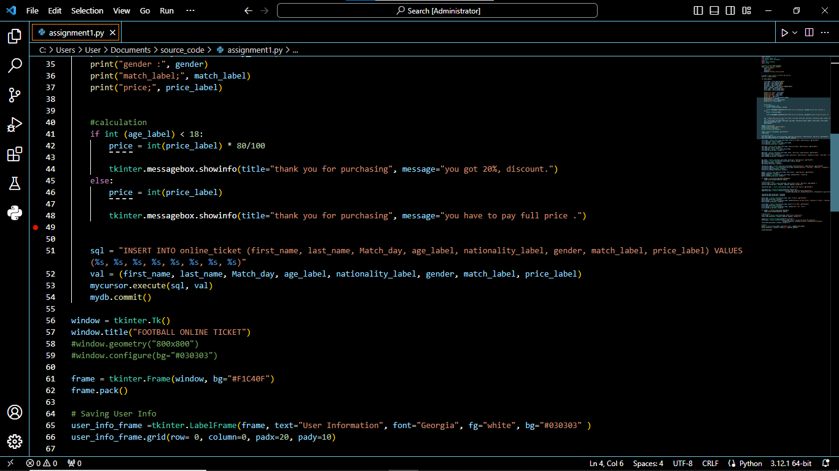

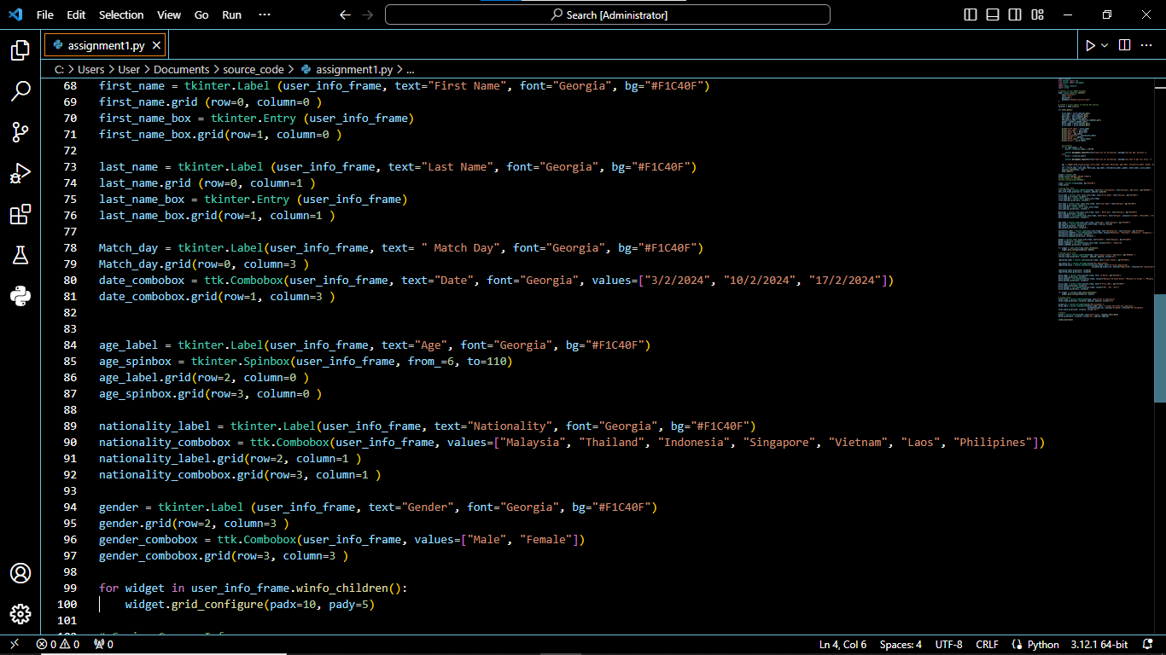

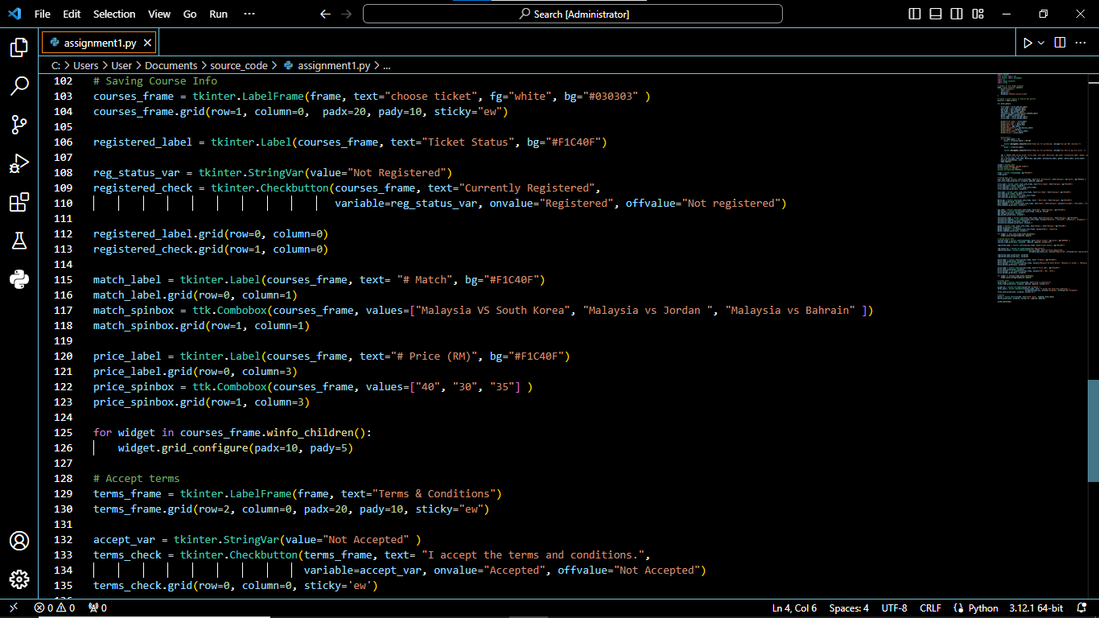

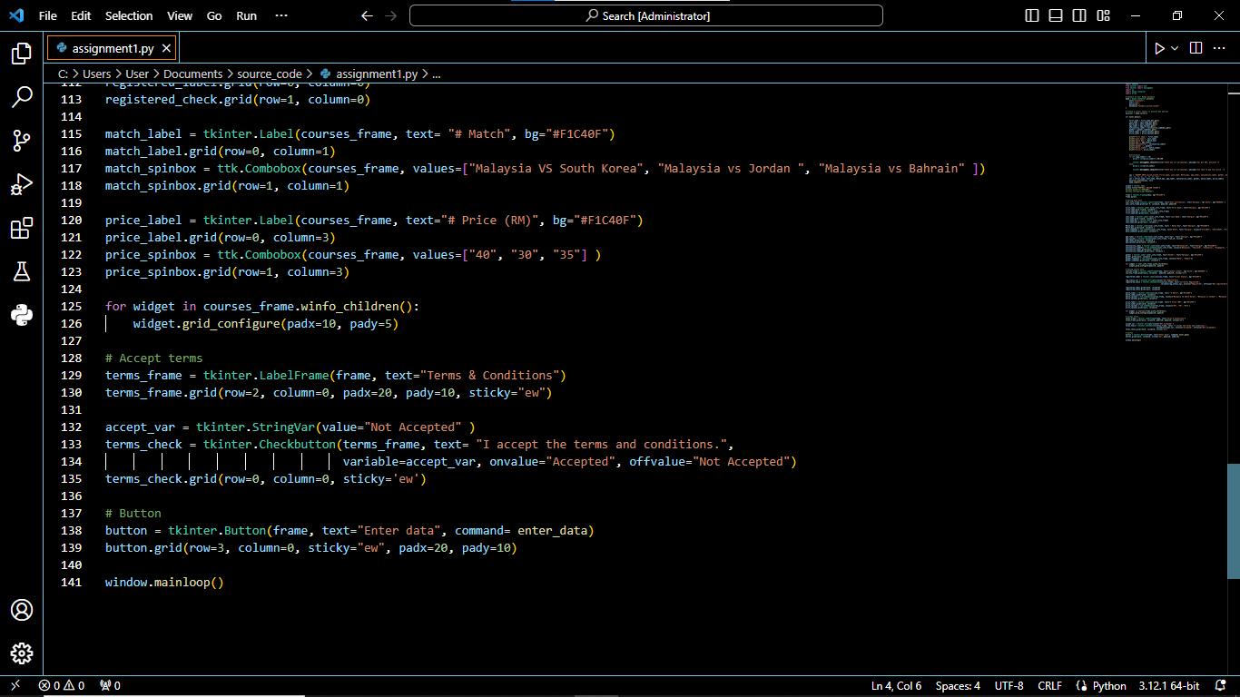

CONCLUSION

In conclusion, In today’s digital age, it’s crucial to communicate with computers as they play a vital role in our daily lives. As more services and products are digitized, programming skills will become increasingly important, and the demand for jobs requiring coding expertise will skyrocket.

It is an essential tool that enables us to communicate with computers and complete tasks. It has a wide range of uses, from managing businesses to creating new products. The importance of computer programming cannot be understated. It helps us solve problems and carry out tasks more efficiently.

In today’s world, computer programming is essential due to the high level of automation. It enables individuals to control the interaction between humans and machines. With the help of computer programming, computers and devices can perform tasks efficiently and accurately.